APPENDIX B

Calculation of the number density threshold

Here we calculate the condition on the electron number density per unit thickness of a 2DES in order to restrict all its constituent electrons to the ground state of the potential well forming the system.

Consider a 2DES of area A and temperature T, consisting of N identical electrons with effective mass m* and energies E. For electron number conservation we have

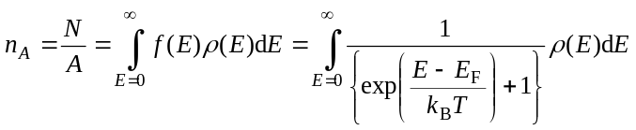, 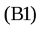

where f is the Fermi distribution function,is the density of states,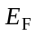 is the Fermi energy and 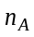is the electron number density of the system.
We now calculate the constraint onso that is less than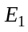, the ground state energy of the potential well used to construct the 2DES, given by

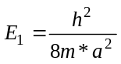, 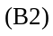

where a is the width of the well.
In a 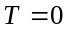 approximation, where

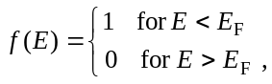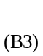

electrons in the 2DES are completely confined to the well ground state and their motion restricted entirely within a two-dimensional plane.
Now recall the form of the density of states displayed in Fig. 2.2, displayed here again in Fig. B1.

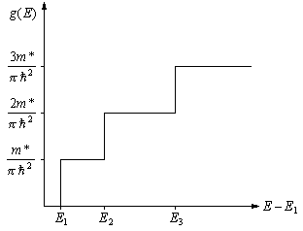

Fig. B1 The density of states per unit physical area of a 2DES confined within an infinite square potential well of width a.

We see that for all electrons in the system to be confined to the well ground state, we require that

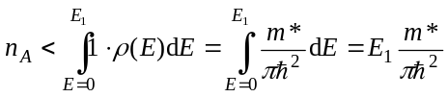. 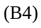

therefore

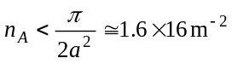, 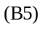

for a typical well width of 10 nm.

